Interactive COVID-19 Vaccination Geo Dashboard Using Bokeh Server

Coursework Report(COHNDDS25.2F-003)

01 Introduction

This project is focused on geospatial data visualization using python and the bokeh server. The domain chosen for the coursework is Geo Data Visualization, where the vaccination rates of the different countries using real-time COVID-19 vaccination data are analyzed.

The main aim of the project is to create a web application using python where the user is allowed to explore the vaccination rates of different countries over a period of time. The application is interactive and allows the user to perform real-time interactivity using the bokeh server application.

The components used in the project includes:
- Vaccination rates (data- .csv format )
- Geographic country data (GeoJSON format)
- Interactive visualization components (slider, dropdown, tools, hover)

The final output is a live choropleth world map where the countries are colored based on the vaccination rate percentage.

02 Data Source and Preprocessing

02.1 Data Sources

The project uses two main datasets

01 COVID-19 Vaccination Dataset (CSV)

contains:
- country
- iso_code
- date
- total_vaccinations
- people_vaccinated
- people_fully_vaccinated
- new_deaths
- population
- ratio (vaccination percentage)

02 Countries GeoJSON File

contains:
- Country boundaries (polygon shapes)
- ISO 3-letter country codes
- Country names

02.2 Data Cleaning and Preparation

several preprocessing steps were performed visualization. First ,The date column converted to datetime format using pd.to_datetime() to standadize date format after that datetime converted to string format to prevent JSON serialization errors in bokeh. After that in ISO_code variable removed extra spaces using .str.strip() and converted it to uppercase finally removed invalid codes like -99, because of that it’s perfectly merging between CSV and GeoJSON data.

After that using fillna(0) filled the missing values with 0 in vaccination numbers, and also default country name fallback for unmatched values. The vaccination dataset was merged with the GeoJSON using ISO_code as the primary key, also used left join to get the all country shapes. Finally created a new variable call ratio that represent the vaccination percentage. The formula is vaccination rate (%) = people_fully_vaccinated/population * 100
this value used for color mapping in the choropleth visualization.

03 Bokeh Visualization Design

03.1 Choropleth Map

A world map is created using figure() and p.patches() used to draw the shapes. Each country is given a color according to the percentage of vaccination using the LinearColorMapper and YlorRd color palettes. In this section, the darker color indicates a higher vaccination rate, whereas the lighter colors indicate a lower vaccination rate.

03.2 Interactivity Features

The dashboard contains the following features;

01 Date Slider
• Users can navigate through different dates.
• Dynamic map changes according to the date.
• Shows the vaccination progress over time.

02 Country Filter Drop Down
• Users can select the data for a specific country.
• Users can select 'All' to view the global data.
• Users can select a specific country to view the data.

03 Hovel Tool

Displays the data for a specific country.
• Country Name
• Vaccination Rate
• People Vaccinated
• Total Vaccinations
• New Deaths

04 Color Bar Legend

A dynamic color bar is included to display the following information:
• Minimum Vaccination Rate(0%)
• Maximum Vaccination Rate(100%)

05 Zoom and Pan Tool

The world map offers the following features:
• Pan
• Wheel Zoom
• Reset
• Save

04 Hosting Procedure

04.1 Environment Setup

For this Dashboard I used A dedicated conda environment call Visualization with python, bokeh and other important packages.

04.2 Folder Structure

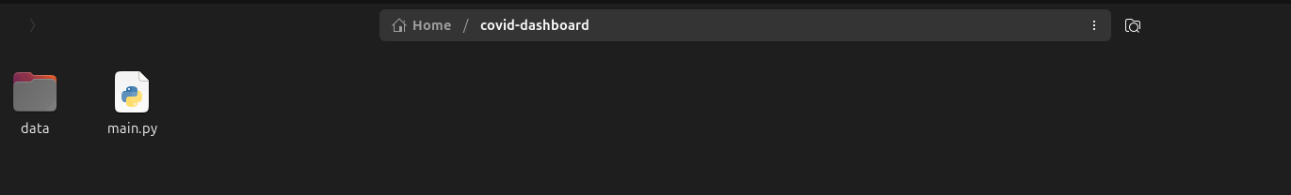

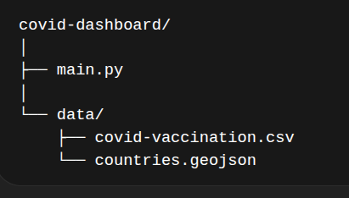

04.3 Running the Application

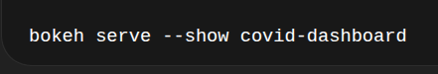

The dashboard was accessed at

Final Output

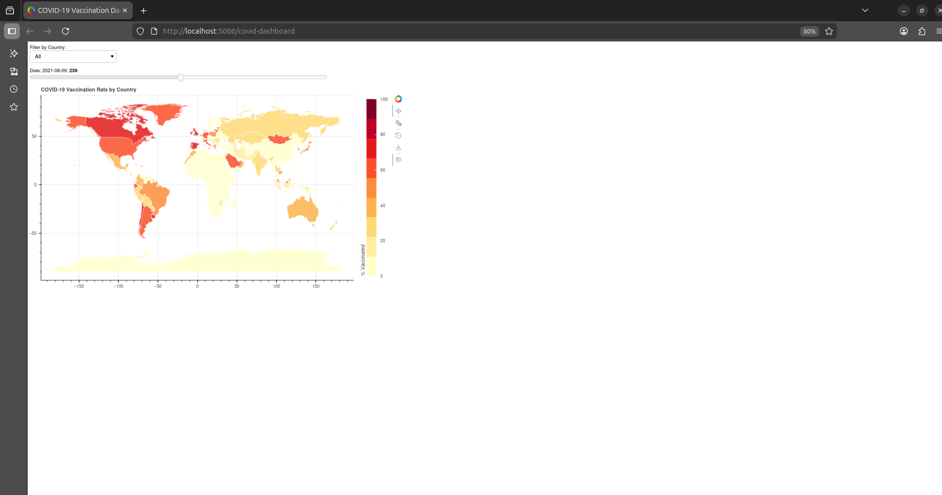

05

05 Challenges faced

During the development, a number of technical challenges were encountered.

01 Module Installation Errors
• Missing geopandas module
• Environment mismatch issues

02 File Path Errors
• Incorrect CSV file location and also the GeoJSON file

03 JSON Serialization Error
• Datetime objects are not JSON serializable
• This problem is solved by converting the dates to string format

04 Country Matching Issues
• ISO code inconsistencies
• Missing country mappings

06 Improvements and Future Works

Even though the dashboard is working correctly, a number of improvements can be made in the future. Some of the possible improvements are as follows:
• Adding metric selector for Vaccination vs Deaths
• Adding country click event with line chart
• Deploying dashboard to the cloud platform
• Improving the UI design and styling
• Adding animation for the automatic progression of the timeline.

These improvements will help in enhancing the dashboard.

07 Conclusion

This project successfully demonstrates the integration of tabular data and geospatial data to develop an intractive visualization dashboard.

The Bokeh server framework is used to develop the dashboard. This framework offers the ability to develop interactive dashboards. This project meets all the required parameters and criteria.

- Data integration
- Advanced plotting features
- Hosting and Accessibility
- Report Quality
- Creativity

The final result is a functional, intractive geo-dashboard that provides meaningful insights into global COVID-19 vaccination trends.

